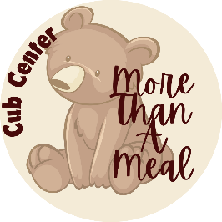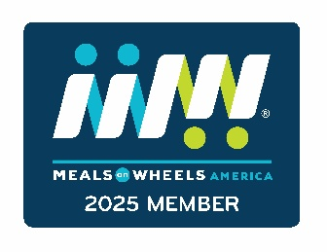
Young County Olney Senior Cub Center
302 S Avenue B
Mailing: PO Box 216
Olney, Texas 76374
www.olneyscc.org | facebook.com/OlneySeniorCubCenter

December 18, 2025

Dear Meals on Wheels Supporter,

It's that time of year again! What happens during the Subaru Share the Love event, you ask....

During the event, those who purchase or lease a Subaru from a Subaru retailer have a choice to benefit one of several charities, including Meals on Wheels. If you buy a Subaru, choose Meals on Wheels as your charity. A gift in the amount of $250 is given to participating Meals on Wheels providers. That means your purchase benefits your community!

Olney Meals on Wheels is provided by the Young County Olney Senior Cub Center inc. We deliver approximately 65 meals to those over 60 who have a hard time making meals and those under 60 who have severe mobility issues. So let's work together to spread a little more love!

If you have any questions or would like more information, please reach out to me at the number below Monday - Friday 8am to 2pm.

Thank you for all the ways you help support the center!

Kind regards,

Angela Lockard
Executive Director
940-564-2782
Young County Olney Senior Cub Center, inc
PO Box 216, Olney, TX 76374

Vision Statement: Let no hungry mind, body, or spirit go unfed in our community and surrounding area! 

